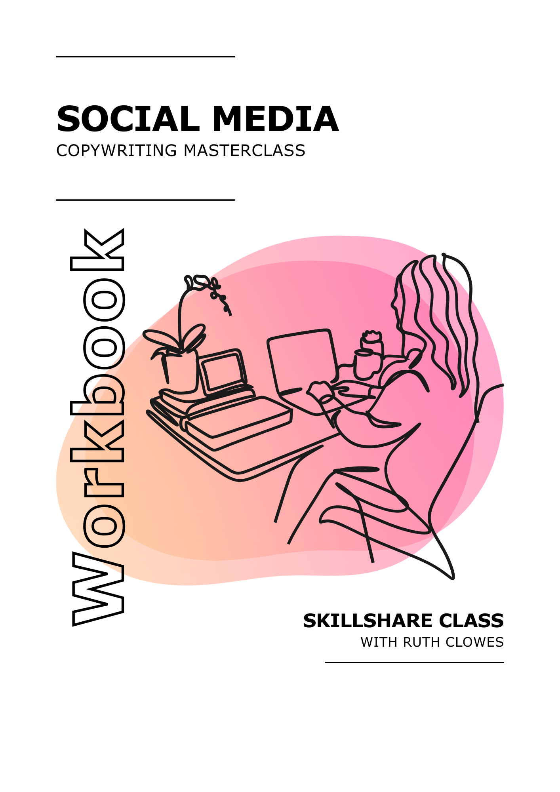
Get ready to supercharge your social media copywriting!

Welcome to this workbook, your companion to my Social Media Copywriting Masterclass on Skillshare. It highlights key takeaways and exercises for real-time application. Download it or print it to complete each section by hand.

Your class project is to write a series of social media posts using skills from the class. Follow along in the workbook, applying techniques to your project.

Thank you so much for choosing to learn from me. It’s a real privilege to guide you through this part of your professional journey.



What’s Inside:

Prepare for Success 3
Profiles and Bios 4
Facebook 5
Instagram 6
LinkedIn 7
X/Twitter and Similar 8
YouTube 9
TikTok 10
Pinterest 11
Reddit 12
Conversations 13
Cross-Platform Strategies 14
Tone of Voice Checklist 15
Evolve and Grow 16
Next Steps 17
My Notes 18

Prepare for Success
Lay the groundwork before you write

Key takeaways

- Social media copy needs to be clear, focused, and easy to skim.
- Planning ahead helps you write faster and more consistently across platforms.
- Use the MART template to clarify your message, audience, response and tone.

-

Try it

Fill out the MART template below for your campaign or brand. Keep it brief and specific – you’ll refer back to this later in the class.

Message - What’s the one thing you want to say?

Audience - Who are you speaking to?

Response - What do you want them to think, feel or do?

Tone - How should your message sound?

-

Reflect

Which part of MART felt easiest to complete? Which part do you need to think more about as you plan your posts?

Profiles and Bios
Make a confident first impression

Key takeaways

- Your bio is often the first thing people see – make it accurate and engaging.
- Use the name field to add keywords that help people find you.
- A strong bio includes:
  - Who you help and how
  - What makes you unique
  - Proof or credibility
  - A CTA with a clear benefit
- Your bio should guide readers into your marketing funnel, not just introduce you.

-

Try it

Draft or update your social media bio using the structure above. Keep it short, specific, and focused on the reader.

-

Reflect

How well does your bio reflect your brand’s tone of voice? Is it clear what makes you different?

Facebook
Write short posts that stop the scroll

Key takeaways

- Facebook favours posts that spark immediate engagement – keep it short and impactful.
- Aim for 40–80 characters and avoid links where possible.
- Write posts like headlines: punchy, clear, and in title case.
- Use numerals to catch the eye and make your message more concise.
- Speak directly to your reader using “you” for a more personal tone.

-

Try it

Write a Facebook post (no more than 80 characters) promoting your campaign. Use at least one of the techniques from this lesson: title case, a number, or the word “you”.

-

Reflect

Which of these tactics felt most natural for your brand? Which one are you likely to use most often, and why?

Instagram
Create posts that connect visually and emotionally

Key takeaways

- Instagram is highly visual, but strong copy is key to engagement and results.
- Captions should work with your images – together they should tell a coherent story.
- Adding dynamic text to images helps grab attention and improves accessibility.
- Sharing customer stories builds trust and authenticity – let their experiences do the talking.
- Use line breaks to make longer captions more inviting to read.
- Staying current with Instagram’s features and algorithm changes helps you stay visible
-

Try it

Draft an Instagram caption that pairs with an image you’ve used or plan to use. Make sure your caption adds meaning or intrigue to the image. Then, reformat the text using line breaks to make it easier to read.

-

Reflect

Could you gather a story or quote from a customer or supporter to use in a future post? How might you feature that visually?

LinkedIn
Write persuasive posts that spark action

Key takeaways

- LinkedIn posts should be professional, credible and conversation-starting.
- The purpose of your post is to persuade the reader to take the next step.
- Questions (especially open-ended ones) draw readers in and boost engagement.
- Naming your audience makes your content feel more relevant and targeted.
- Post copy and link titles should work together smoothly – readers will see both at once.

-

Try it

Write a LinkedIn post for your campaign using one of these techniques: start with a question, name your audience directly, or pair your copy with a strong content title.

-

Reflect

Which technique felt most natural for your brand or voice? Which one are you keen to experiment with more?

X/Twitter and Similar
Write short posts with big impact

Key takeaways

- Short-form platforms reward brevity – aim for fewer than 100 characters where possible.
- Strip out unnecessary adjectives and adverbs to tighten your message.
- Break traditional grammar rules to add rhythm and punch.
- Use short sentence fragments to make posts more dynamic and easier to scan.
- Hashtags can double as formatting – they draw attention to key phrases.

-

Try it

Write a post for a short-form platform using one of these tactics: cut extra words, break a grammar rule, or turn a key phrase into a hashtag for emphasis.

-

Reflect

Which part of your original message was hardest to cut? What helped you decide what to leave out?

YouTube
Write scripts that keep viewers watching

Key takeaways

- YouTube is ideal for long-form, in-depth content – but audience engagement is still key.
- Start scripts with a strong hook to grab attention quickly.
- Use clear structure and pacing – break down content with signposts like “First” and “Next”.
- Write in a conversational tone – use short sentences, contractions and the word “you.”
- Reading your script aloud helps catch awkward phrasing and improve rhythm and clarity.

-

Try it

Write a short script intro (2–3 lines) for a video promoting your chosen message. Focus on the hook and tone – aim to sound clear, conversational and natural.

-

Reflect

Read your draft out loud. Did anything feel awkward or flat? What would you tweak to make it sound more like you?

TikTok
Tell powerful stories in just a few seconds

Key takeaways

- TikTok is ideal for creative, short-form storytelling with a casual, high-energy tone.
- The ‘Quest–Triumph–Reward’ structure is perfect for quick, effective videos.
- Captions improve accessibility and engagement – add them manually or with in-app tools.
- Behind-the-scenes content, mistakes, polls and challenges all feel authentic.
- Use time-sensitive offers and power words (e.g. “Now”, “Limited time”) to create urgency.

-

Try it

Sketch out a TikTok idea using the ‘Quest–Triumph–Reward’ format. Add a working title, a caption idea, and one interactive element (e.g. a poll, challenge, or comment prompt).

Quest – A desire or problem your reader can relate to

Triumph – Introduce your brand as the solution to the quest

Reward – Highlight the rewards or benefits of the triumph

-

Reflect

What type of content feels most natural for you to share: story-led, behind-the-scenes, or offer-based? Why?

Pinterest
Write Pins that get found – and clicked

Key takeaways

- Pinterest works like a visual search engine – SEO matters.
- Choose 1–2 strong keywords that reflect your content and use them consistently.
- Use the description to expand on your message and add secondary keywords.
- Boost conversions by including:
  - Your business name early in the description
  - A clear call to action
  - Pricing info, if relevant

-

Try it

Write a Pinterest title and description for a Pin that links to your content. Use a clear keyword in both, but don’t repeat the same wording. Add either your business name, a CTA, or a price.

Title

Description

-

Reflect

What keyword or phrase do you want your content to rank for on Pinterest? How consistently are you using it across your copy?

Reddit
Join the conversation with honesty and insight

Key takeaways

- Reddit users value authenticity, community spirit and useful contributions.
- Spend time in each subreddit before posting.
- Add value first – through helpful comments, advice, insights or genuine questions.
- Write in a conversational tone – avoid brand-speak, jargon, or sales-y language.
- Subtle brand promotion works best when it’s secondary to the conversation.

-

Try it

Draft a Reddit post for a relevant subreddit in your niche. Start a conversation or ask a question that feels natural and community-focused. Keep the tone casual and avoid any overt promotion.

-

Reflect

How could your brand contribute to a subreddit as a helpful, credible voice? What kinds of posts would feel appropriate and valuable?

Conversations
Respond with authenticity, clarity and care

Key takeaways

- Comments, replies and DMs are where real connection happens – how you respond matters.
- Avoid copy-paste replies – instead, prepare a bank of varied responses to choose from.
- Match the tone of the person you’re replying to – casual or formal – to show you’re listening.
- Use names, sign off personally, and add small touches of humour or warmth.

-

Try it

Choose a common comment or message you receive. Write three different variations of a response – try shifting tone, adding a name, or including a question to continue the conversation.

Comment

Response 1

Response 2

Response 3

-

Reflect

How do your current responses sound when read back-to-back? Could small changes help them feel more thoughtful and less repetitive?

Cross-Platform Strategies
Keep your voice consistent while adapting your tone

Key takeaways

- Repurposing content saves time and increases reach – adapt don’t duplicate.
- Avoid copy-pasting the same post– tweak the format, tone and CTA to suit each platform.
- Reposting isn’t lazy – don’t be afraid to repeat strong content.
- Your brand voice should be consistent, but your tone can shift to match each platform’s style

-

Try it

Take one message or piece of content from your project and write three short post variations – one each for Instagram, LinkedIn and a short-form platform like X or Threads.

Message

Platform 1

Platform 2

Platform 3

-

Reflect

Revisit the 2–3 words you chose to describe your brand’s voice earlier. Do these variations still reflect that voice across platforms?

Tone of Voice Checklist
Use this quick check before you publish a post on any platform.

- Am I staying true to my brand voice?

☐ Does this sound like my brand?
☐ Does it reflect the adjectives I chose earlier (e.g. friendly, confident, playful)?
☐ Is the message clear and consistent with my other content?

-

- Is the tone right for this platform?

Facebook / Instagram
☐ Is it friendly and conversational?
☐ Does it feel natural and scroll-stopping?
☐ Is the image or video doing some of the talking?

LinkedIn
☐ Is it more polished and professional?
☐ Does it offer insight or value to a work-focused audience?
☐ Am I keeping it clear and confident without being too casual?

X / Twitter and Similar
☐ Is it short, punchy, and to the point?
☐ Is it engaging enough to encourage interaction?
☐ Have I included hashtags or tags if relevant?

TikTok / Reels / Shorts
☐ Is the message quick and easy to follow?
☐ Does it sound human and unscripted?
☐ Does it fit with the style of video I’m posting?

-

- Am I speaking to real people?

☐ Does it sound like something a real person would say?
☐ Would I say this out loud in a conversation?
☐ Have I avoided jargon or unnecessary waffle?

- Final quick check

☐ Spelling and grammar ok?
☐ Does this post make me want to click, like, or share?
☐ Would I be proud to share this from my personal account?

Evolve and Grow
Keep your copy fresh in a changing landscape

Key takeaways

- Social platforms and audience behaviours change constantly – staying informed is essential.
- Follow trusted news sources, blogs, and platform updates to keep your knowledge current.
- Experiment with new features, content types and CTAs – then analyse your performance.
- Ask your audience what they want, and keep an eye on what your competitors are doing well.
- Use language trends with care – be relatable without forcing it.
- Watch for emerging platforms and consider testing content early to build a foothold.

-

Try it

Complete this short action plan:

One platform I want to understand better:

One content experiment I’d like to try:

One trend or topic I’ll keep an eye on:

-

Reflect

What’s one change you could make this month to help your brand stay relevant on social media?

Next Steps

Thank you for taking part in this class and congratulations on all your hard work!

You’ve learned practical techniques you can use straight away to craft engaging and effective content for your social media posts.

To view my full collection of Skillshare copywriting classes, visit my profile page at skillshare.com/r/ruthclowes. Don't forget to hit 'Follow' to receive updates whenever I launch a new class.

Again, thank you for joining me in this journey. It's been a pleasure to share my knowledge with you. Enjoy the rest of your day, and here's to your success in social media copywriting!



My Notes

