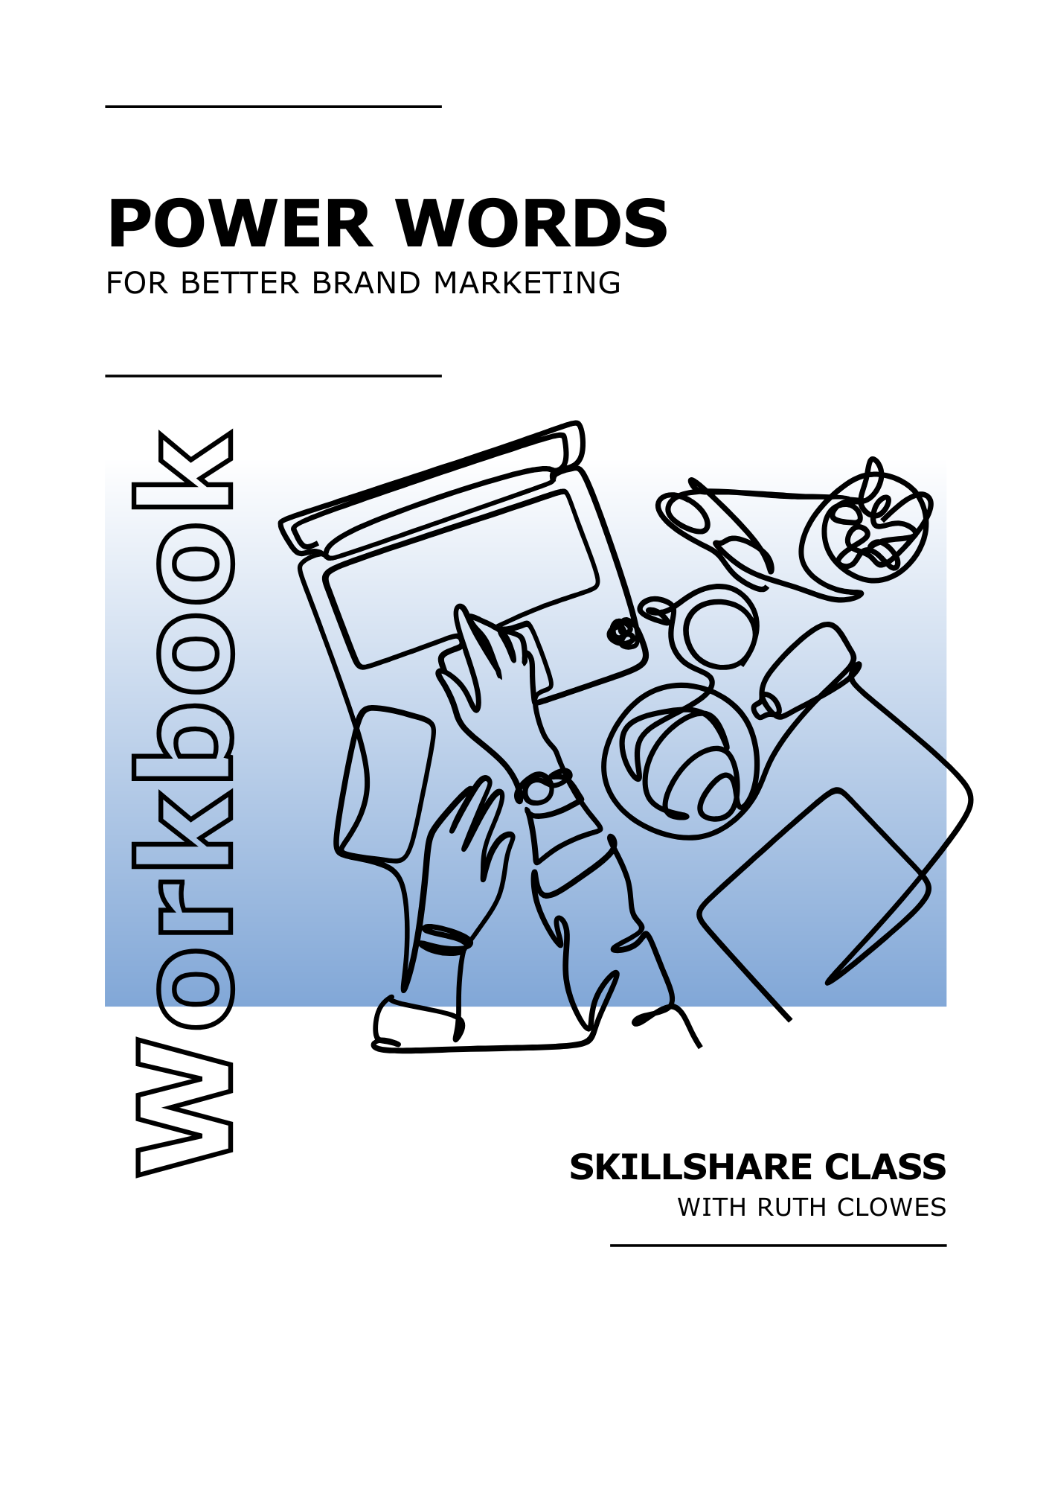
Get ready to supercharge your marketing copy!

Welcome to this Workbook, your companion to my Power Words Skillshare class. It highlights key takeaways and contains lists of example power words for inspiration. Download it or print it to complete each section by hand.

Your class project is to craft a short piece of copy - a social media post, headline, or webpage title - using one or more power words. Use this Workbook as a source of ideas and a place for experimentation.

Going forward, make power words a regular part of your copy. Test different ones, track engagement, and see what resonates most with your audience. Keep experimenting to find the right mix for your brand.

Thank you so much for choosing to learn from me. It’s a real privilege to guide you through this part of your professional journey.



What’s Inside:

Power Word Essentials 3
Curiosity Power Words 4
Excitement Power Words 5
Trust Power Words 6
Urgency Power Words 6
Motivating Power Words 8
Sensory Power Words 9
Next Steps 10

Power Word Essentials

Power Words Spark Emotion and Action

Power words trigger emotion, create engagement, and encourage action. They make marketing copy more compelling by adding energy, urgency, or trust.

Placement Matters

Use power words strategically in headlines, CTAs, and key messages. The right word at the right time can be the difference between engagement and being overlooked.

Balance is Key

Too many power words can make writing feel exaggerated. Use them where they add value, but keep the rest of your copy clear and natural.

Truthfulness Builds Trust

Power words should enhance your message, not mislead. Only use words like exclusive, guaranteed, or proven if they’re factually accurate - honesty strengthens credibility.

Categories Overlap

Power words don’t fit into strict categories - many work in multiple ways. Focus on choosing the right word for the moment rather than worrying about labels.

Experiment and Track Engagement

Different words resonate with different audiences. Try out power words in your copy, track engagement, and adjust based on what works best.

Curiosity Power Words

Spark interest and make people want to learn more

Mystery  Secret  Hidden  Uncover  Unlock  Behind the scenes  Exposed  Revealed  Little-known  Insider | Rarity  Special  Once-in-a-lifetime  Untold  Rare  Uncommon  Only known to
Learning  Discover  Learn  Explore  Find out  Unearthed  Unveiled  The truth about  Did you know? | Surprising  Unexpected  Shocking  Bizarre  Strange but true  Weird  Unusual  Game-changing

Notes

Excitement Power Words

Add energy and enthusiasm to your copy

Cutting-Edge  New  Latest  Breakthrough  Revolutionary  Fresh  Next-level  Unprecedented | High Energy  Exciting  Thrilling  Amazing  Incredible  Must-have  Unmissable  Jaw-dropping  Mind-blowing  Sensational
Exclusivity  Limited  Exclusive  One-time-only  First access  VIP  Special offer | Action  Jumpstart  Kickstart  Fast-track  Instant  Lightning-fast  Turbocharge

Notes

Trust Power Words

Reassure readers and build credibility

Tested  Proven  Tested  Certified  Backed by science  Research-backed  Expert-approved  Evidence-based | Authority  Experienced  Professional  Industry-leading  Accredited  Endorsed  Verified
Security  Safe  Secure  Guaranteed  Reliable  Risk-free  Trusted  Protected | Satisfaction  No-risk  Money-back guarantee  100% satisfaction  No hidden fees  Authentic  Tried and tested

Notes

Urgency Power Words

Encourage people to act fast by creating a sense of time pressure

Time-Sensitive  Limited time  Only X left  Act now  Hurry  Don’t wait  Last chance  Final call  Selling fast  Going fast | Instant Action  Right now  Immediate  Get it now  Grab yours  Claim today  Instant access
Deadlines  Today only  Ends soon  While supplies last  Offer expires  Closing soon  Countdown  Last opportunity | Fear of Missing Out (FOMO)  Don’t miss out  Gone forever  Before it’s too late  Once it’s gone, it’s gone

Notes

Motivating Power Words

Make readers feel capable, confident, and ready to take action

Achievement  Master  Achieve  Conquer  Succeed  Win  Elevate  Unlock your potential  Reach your goals  Take control  Break through | Self-Belief  You can  Confidently  Unstoppable  Step up  Build  Own your future  Take charge
Growth  Transform  Change  Improve  Strengthen  Supercharge  Reinvent  Make it happen  Level up | Progress  Start now  Move forward  Get results  Small steps, big impact  Take action today

Notes

Sensory Power Words

Bring descriptions to life by engaging the senses

Sight  Vibrant  Sparkling  Golden  Rich  Radiant  Bright  Deep  Glossy | Sound  Whisper  Crackle  Rustle  Echoing  Sizzling  Melodic  Hushed  Booming  Crisp
Touch  Silky  Soft  Smooth  Plush  Rough  Velvety  Snug  Cooling | Taste and Smell  Zesty  Tangy  Sweet  Savoury  Aromatic  Smoky  Freshly baked  Earthy  Buttery

Notes

Next Steps

Thank you for taking part in this class and congratulations on all your hard work!

You’ve learned how to identify, select, and apply power words that spark emotion, boost engagement, and inspire action. With these new skills, you’re all set to write compelling, high-impact copy that drives real results.

To view my full collection of Skillshare copywriting classes, visit my profile page (skillshare.com/r/ruthclowes). Don't forget to hit 'Follow' to receive updates whenever I launch a new class.

Again, thank you for joining me. It's been a pleasure to share my knowledge with you. Enjoy the rest of your day and have fun using power words to boost your marketing copy.



